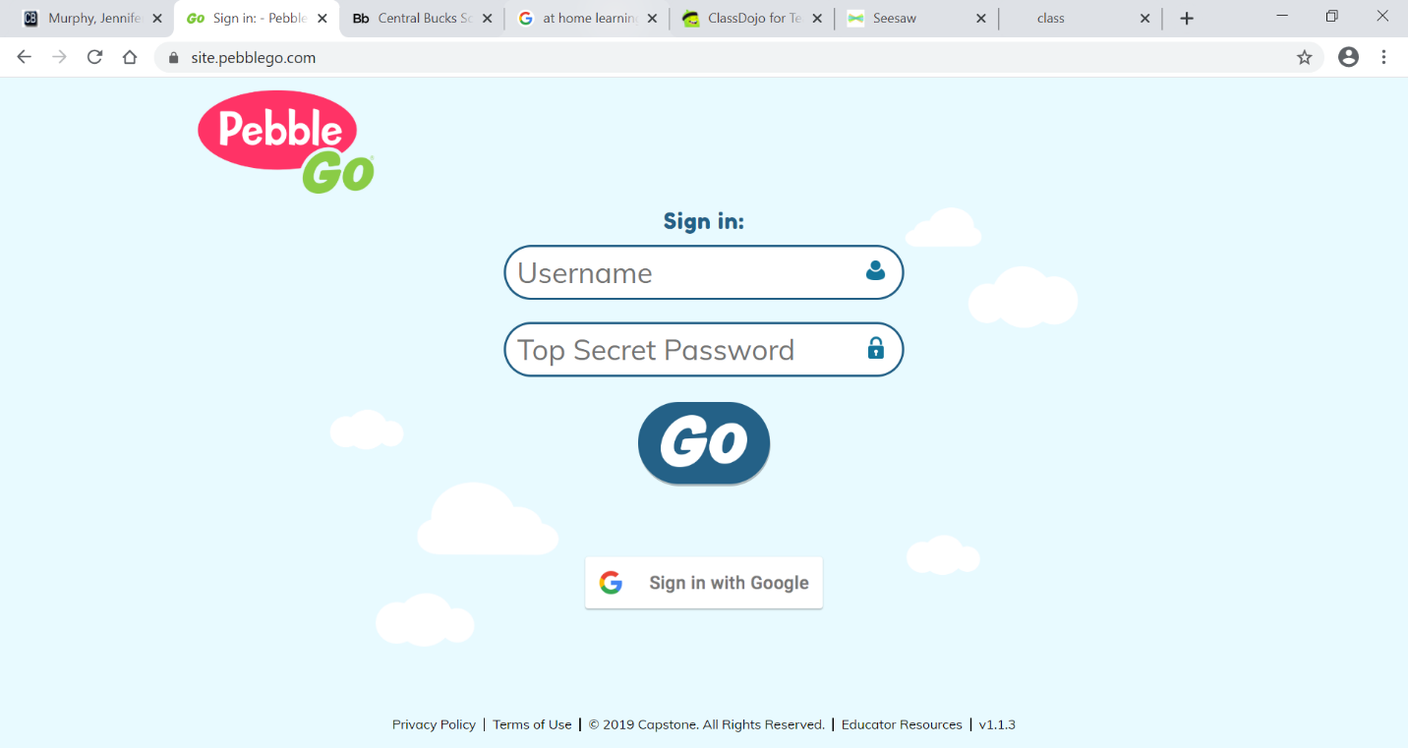
Click https://site.pebblego.com/
Username: cblib
Top Secret Password: school

